1. **Agenda:**
   1. Logging some metadata info about the record after receiving the response from Broker.
2. We can print the following info.  
   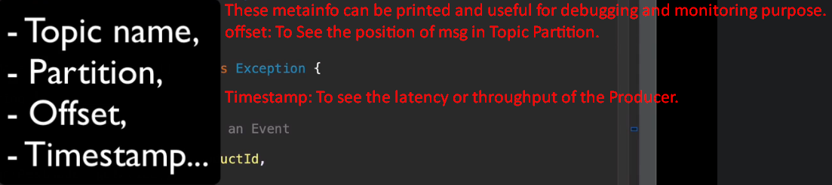
3. 